***SPIRIT TELECOMMUNICATIONS***



**Course Number**: MIS 6326.001

**Instructor**: Dr. Young Ryu

**Group Members**:

Krishna Sai Chaitanya Matta

Robin Pappachan

Samuel Kullmer

Sonam Sanjay Mahajan

**Table of Contents**

**1. Organization Background**

1.1 Organization History

1.2 Problem Statement

**2. Database Scope and Table Description**

2.1 Database scope

2.2 Tables

2.2.1 Family table

2.2.2 Members table

2.2.3 Employee table

2.2.4 Stores table

2.2.5 Plans table

2.2.5.1 Top Up plans table

2.2.5.2 Data plans table

2.2.5.3 Roaming plans table

2.2.6 Invoice table

2.2.7 Billing table

2.2.8 Billed Invoices table

**3. Entity-Relationship Diagram**

**4. Relational Database schema**

**5. Data Input screen forms**

**6. Sample Reports**

**7.Menu**

**8. Contributions**

**1. Organization Background**

**1.1 Organization history**

Spirit is a telecommunications company that provides wireless and internet services. Spirit uses CDMA, EvDO and 4G LTE networks. It has stores and customers all over the country. Spirit comes up with attractive TopUp, Data and Roaming plans provided at competitive price. It has the motto of occupying 50% share of telecommunication market by the end of this decade. The Spirit service was first marketed in six metropolitan areas. A customer had to acquire members to form a family group in order to obtain a private line connection. Later, the company has announced incentives in family plans to encourage the customers transferring to their line.

**1.2 Problem Statement**

In the early stage, the company had few customers and limited wireless plans. Customer information and transaction history was maintained in an orthodox fashion by updating the records manually. As the business kept expanding, more stores got opened in cities and the need for workforce has increased significantly to manage the growing customer size and transactions.

The top management has decided to come up with a digital solution for the ongoing problem. They have approached our ‘Software consulting’ group asking for a remedy. We decided to implement a database solution for them which reduces the company’s cost significantly. The database solution helps to have an organization alignment, track of customer information and their transactions. The billing process would be much efficient compared to the more error prone traditional way of pulling transaction history from manually maintained records. It provides the leverage of operating the stores at minimum cost and reduces the need of hiring more workforce. Also, it helps to introduce new plans and revise its old plans quickly.

The current database solution is aimed to provide in-store assistance. But, in future a web application could be built on top of it to render online services

**2.Database Scope and Table Description**

**2.1 Database scope:**

The database has three major functions. The primary function is to keep a track of the usage of the customers. Usage is tracked based on plans activated by each member of a family. The database serves to provide an efficient way to track the billing information of all its customers. The secondary functions would be to keep a track of the plans available to the customers which further enables the company to analyse which plans are the cash generators and which require to be further improved. As and when new plans are introduced in the market by Spirit Telecommunication the plans would be updated in the database, the number of users activating the plan will also be updated within the database. Another function is to keep a record of the employees, managers and the respective stores that they each belong to. The database makes use of 11 tables to keep a record and track the above-mentioned information, each of which are described below:

**2.2 Tables:**

**2.2.1 Store Table:** The store table keeps a record of all the Spirit Telecommunication stores across the country. The table has five attributes each comprising of a part of the address of the store. The primary key is the **StoreID,** the other attributes in the table are **StoreStreet** (Records the street number and other adjoining information of the location), **StoreCity** (The city in which the store is located), The **StoreState** (The state where it is located) and **StoreZip** (Zip code of the location).

**2.2.2 Employee Table**: The Employee table keeps a record of all the employees working at Spirit Telecommunications. It also lists details of the store managers to which the other employees in the store report to. The table has five attributes. The Primary Key is the **Employee ID** which is unique to each employee working at Spirit. We have used the **StoreID** from Store Table acting as the Foreign Key to reference the stores at which employee works. The other attributes are **SupervisorID** (Employee ID of each supervisor), **EmpFirstName** and **EmpLastName** (To keep a record of the employee names).

**2.2.3 Family Table**: Spirit Telecommunication follows a billing system which generates bills on the usage of each family. A family starts with a minimum of 2 members. The family based billing system enables in a more efficient tracking of customers also a bill is sent only to the leader of each family. The table makes use of five attributes the Primary Key is the **FamilyID**. The other attributes are **StreetAddress, City, Zip** which track the address of each family leader. The table also has an **AdvisorID** (Employee ID from the Employee Table) The purpose of the advisor is to make periodic calls to the leaders of every family assigned to them to understand if they have any issues with the service provided by the company. An initiative started by Sprint to improve its customer service quotient.

**2.2.4 Members Table**: The table keeps a record of every customer of Spirit. Each member belongs to particular family. The Primary Key used in the table is **MemberID** (Unique ID assigned to each customer). **FamilyID** is used as Foreign Key to reference to the Family Table. The other attributes are member **FirstName** and **LastName**. The **Email** attribute stores a record of the email of the customer.

**2.2.5 Plans Table**: The Plans table maintains a record of every plan launched into the market by Sprint Telecommunication. All the plans are categorized into three groups as TopUp Plans. Data Plans and Roaming plans. We have used a hierarchical model for the tables here. The Primary Key is the **PlanID** (Unique number assigned to each plan). The other attributes are **Description** (Gives a description of the respective plans), The **ValidyinDays** (Stores a record of the how long the plan is valid for), **Amount** (The charge of the plan).

**2.2.5.1 TopUp_Plans**: The top up plans table keep a record of the plans which provide talktime to customers. The attributes here are the PlanID, which is also the **Primary Key** and TalkTimeMinutes.

**2.2.5.2 Data_Plans**: The Data plans are plans which provide the user with data usage. The attributes are **PlanID,** which is the primary key and **DatalimitGB** (the amount of data which is made available to the user, in GB) and **Speed** (The connectivity of the data pack, whether 3G or 4G data plan).

**2.2.5.3 Roaming_Plans**: The Roaming plans record information on the **RoamingMinutes** made available to the customer and the **RoamingType** this being either domestic or international roaming. The Primary Key is **PlanID.**

**2.2.6 Invoice Table**: Each time a plan is activated by a member an invoice is generated against the member. The Invoice table keep a record of each invoice that is generated. There are four attributes maintained within the table. The **Invoice_ID** is the Primary Key. **Member_ID** and **Plan_ID** are used as Foreign Keys to reference to the Members Table for the particular member and Plan table to list the plan being invoiced. **ActivationData** is another attribute which is kept a track of within the Invoice Table.

**2.2.7 Billing Table**: The Billing Table performs the function of generating a bill against each family at the end of the billing cycle. The Primary Key here in the **BillingID** (A unique ID assigned to each bill that is generated), **BillingDate** (Date of generation of the bill), **DueDate** (Last date of payment of the bill). **FamilyID** is used as Foreign key to reference the bill to the respective family against which the bill has been generated.

**2.2.8 Billed Invoice Table**: As and when a plan is activated an invoice is generated, however the customer is sent a bill only at the end of the billing cycle. The Billed invoice table **keeps a track of all the invoices for which a bill has been sent to the customer**. The Primary Key for the table is the composite of the Primary Keys of the Invoice Table (**Invoice_ID**) and the Primary Key of the Billing Table **(BillingID**). The other attributes are **MemberID** and **Plan_ID**, which are used as Foreign Keys to reference to the Member Table and Plan Table respectively**. Activation Date** of the plan is also kept a record of within this table.

At the end of every month, a **query** needs to be ran to assign the Billing Ids generated to corresponding invoices. This eliminates the tedious task of manually assigning the billing IDs to corresponding invoices in a month pertaining to a family. The table gets dropped and automatically refreshed with data whenever the query is ran after generating the bill using the Billing form.

**3. Entity-Relationship Diagram**

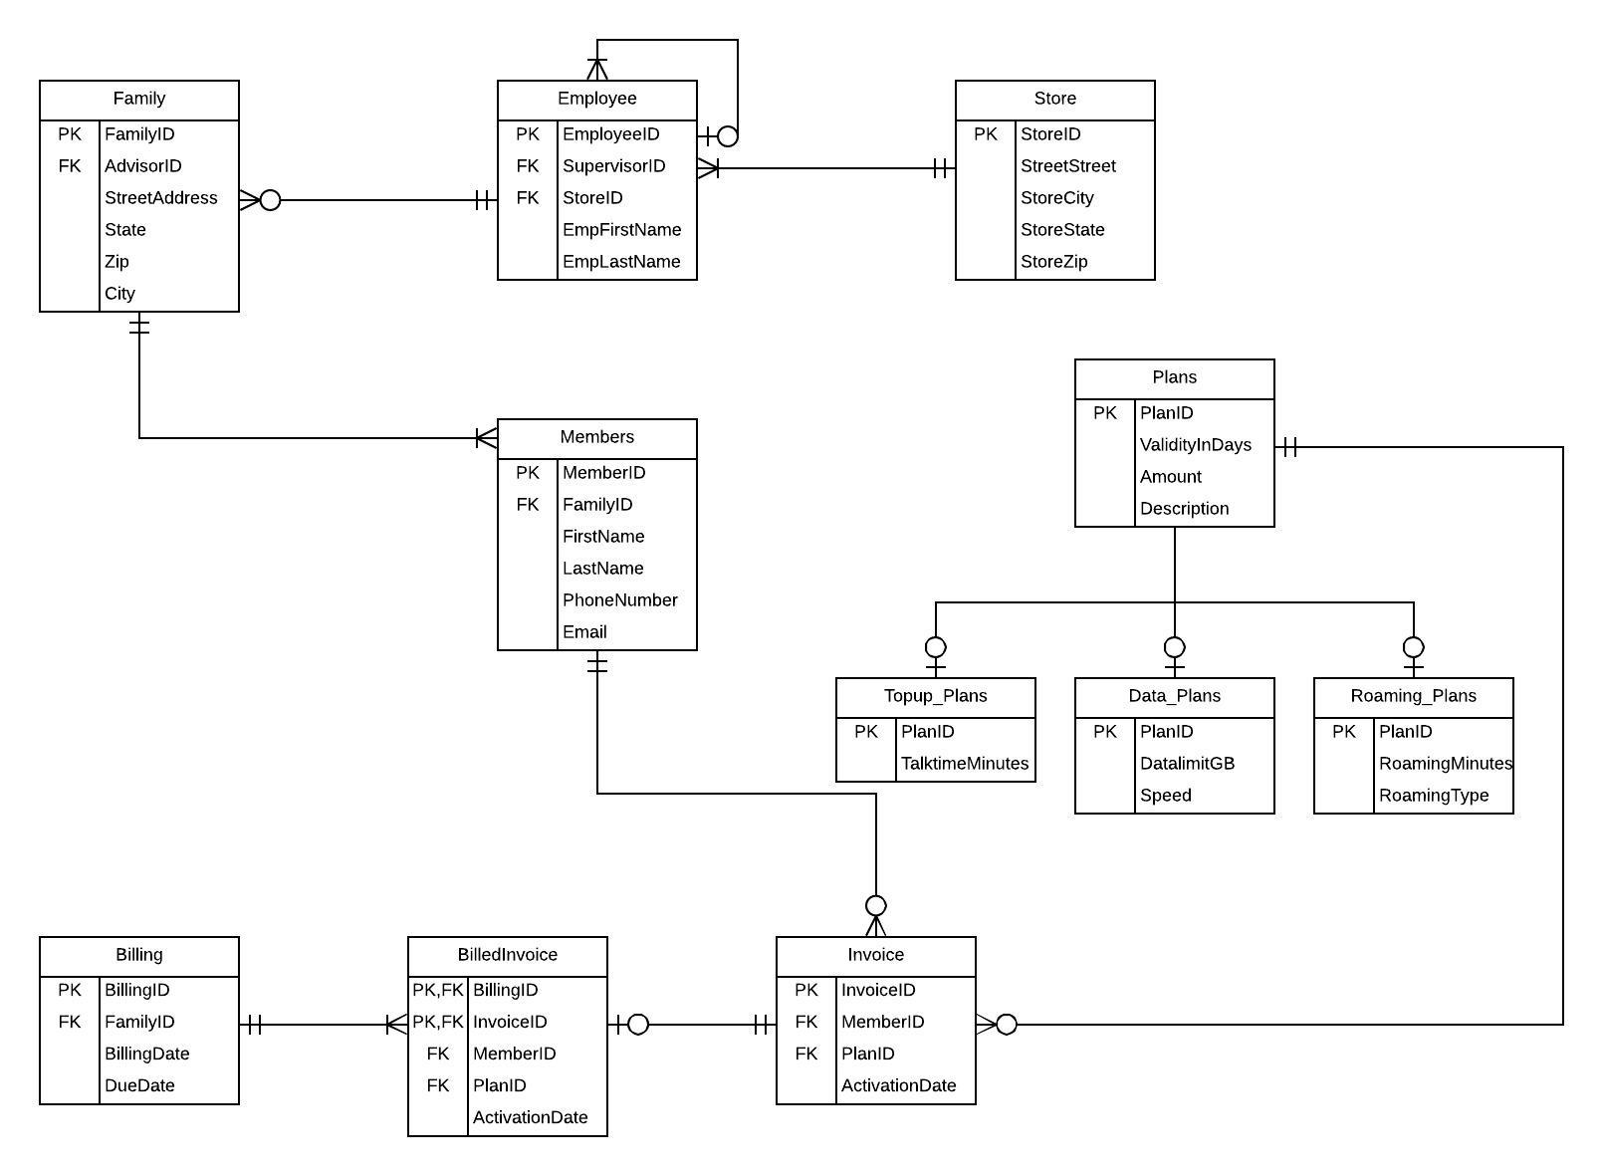

**4. Relational Database Schema**

**Family:**

CREATE TABLE Family

(FamilyID VARCHAR (10),

StreetAddress VARCHAR (20),

City VARCHAR(20),

State CHAR (20),

Zip NUMERIC,

AdvisorID VARCHAR (10),

CONSTRAINT PKFamily PRIMARY KEY (FamilyID),

CONSTRAINT FKAdvisorID FOREIGN KEY (AdvisorID) REFERENCES Employee)

**Store:**

CREATE TABLE Store

(StoreID VARCHAR (10),

StoreStreet VARCHAR (20),

StoreCity VARCHAR (20),

StoreState CHAR (20),

StoreZip NUMERIC,

CONSTRAINT PKStore PRIMARY KEY (StoreID))

**Employee:**

CREATE TABLE Employee

(EmployeeID VARCHAR (10),

EmpFirstName VARCHAR (20),

EmpLastName VARCHAR (20),

SupervisorID VARCHAR (10),

StoreID VARCHAR (10),

CONSTRAINT PKEmployee PRIMARY KEY (EmployeeID),

CONSTRAINT FKSupervisorID FOREIGN KEY (SupervisorID) References Employee,

CONSTRAINT FKStoreID FOREIGN KEY (StoreID) References Store)

**Member:**

CREATE TABLE Member

(MemberID VARCHAR(10),

FirstName VARCHAR(20),

LastName VARCHAR(20),

PhoneNumber NUMERIC,

Email VARCHAR(30),

FamilyID VARCHAR (10),

CONSTRAINT PKMember PRIMARY KEY (MemberID),

CONSTRAINT FKFamilyID FOREIGN KEY (FamilyID) References Family)

**Plan:**

CREATE TABLE Plans

(PlanID VARCHAR(5),

ValidityInDays INTEGER,

Amount CURRENCY,

Description VARCHAR(25),

CONSTRAINT PKPlan PRIMARY KEY (PlanID))

**Topup_Plans:**

CREATE TABLE Topup_Plans

(PlanID VARCHAR(5),

TalktimeMinutes INTEGER,

CONSTRAINT PKTop_upPlans PRIMARY KEY (PlanID),

CONSTRAINT FKTop_upPlans FOREIGN KEY (PlanID) References Plans)

**Data Plans:**

CREATE TABLE Data_Plans

(PlanID VARCHAR(5),

DataLimitGB INTEGER,

SPEED VARCHAR(5),

CONSTRAINT PKData_Plans PRIMARY KEY (PlanID),

CONSTRAINT FKData_Plans FOREIGN KEY (PlanID) References Plans)

**Roaming_Plans:**

CREATE TABLE Roaming_Plans

(PlanID VARCHAR(5),

RoamingMinutes INTEGER,

RoamingType VARCHAR(15),

CONSTRAINT PKRoaming_Plans PRIMARY KEY (PlanID),

CONATRAINT FKRoaming_Plans FOREIGN KEY (PlanID) References Plans)

**Invoice:**

CREATE TABLE Invoice

(Invoice_ID VARCHAR(10),

Member_ID VARCHAR(10),

Plan_ID VARCHAR(5),

ActivationDate DATE,

CONSTRAINT PKInvoice PRIMARY KEY (Invoice_ID),

CONSTRAINT FKMember_ID FOREIGN KEY(Member_ID) References Member,

CONSTRAINT FKInvoicePlan_ID FOREIGN KEY (Plan_ID) References Plans)

**Billing:**

CREATE TABLE Billing

(BillingID VARCHAR(10),

FamilyID VARCHAR(10),

BillingDate DATE,

DueDate DATE,

CONSTRAINT PKBilling PRIMARY KEY(Billing_ID)

CONSTRAINT FKBillingFamilyID FOREIGN KEY (FamilyID) References Family)

**BilledInvoices:**

SELECT * INTO BilledInvoices

FROM (SELECT T.Invoice_ID, T.Member_ID, T.Plan_ID, T.ActivationDate, BillingID FROM Billing, (SELECT FamilyID, Invoice_ID, Member_ID, Plan_ID, month(ActivationDate) AS ActivationMonth, year(ActivationDate) AS ActivationYear, ActivationDate FROM Members, Invoice WHERE Invoice.Member_ID=Members.MemberID) AS T WHERE Billing.FamilyID=T.FamilyID and month(BillingDate)=T.ActivationMonth and year(BillingDate)=T.ActivationYear)

**5. Data Input screen forms**

5.1 Family Form

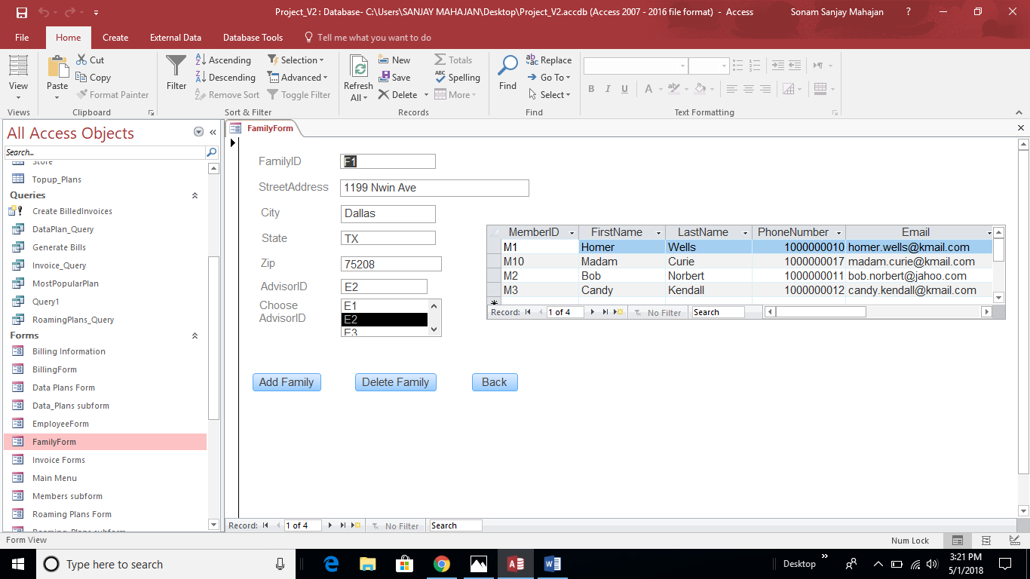

5.2 Employee Form

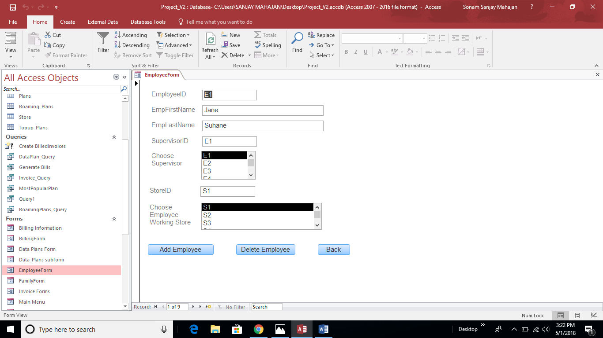

5.3 Store Form

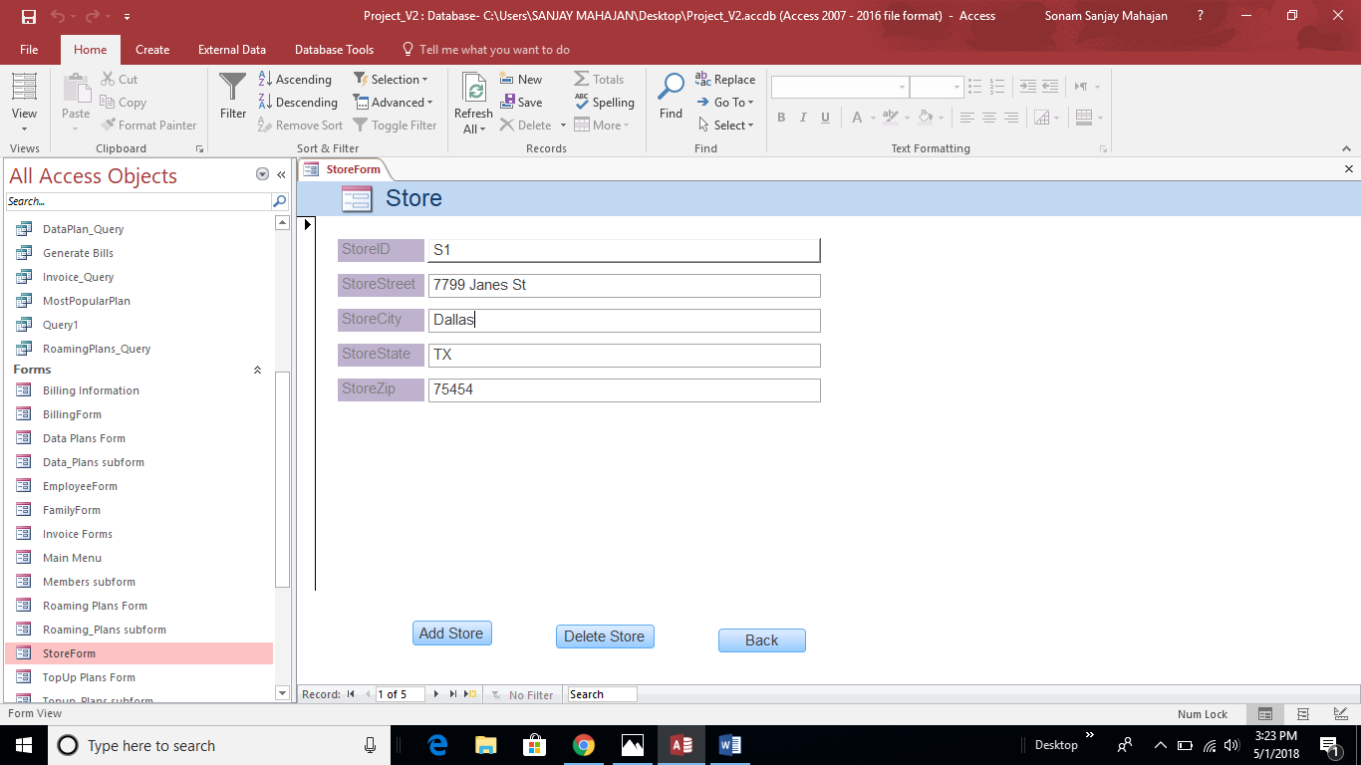

5.4 Billing Form

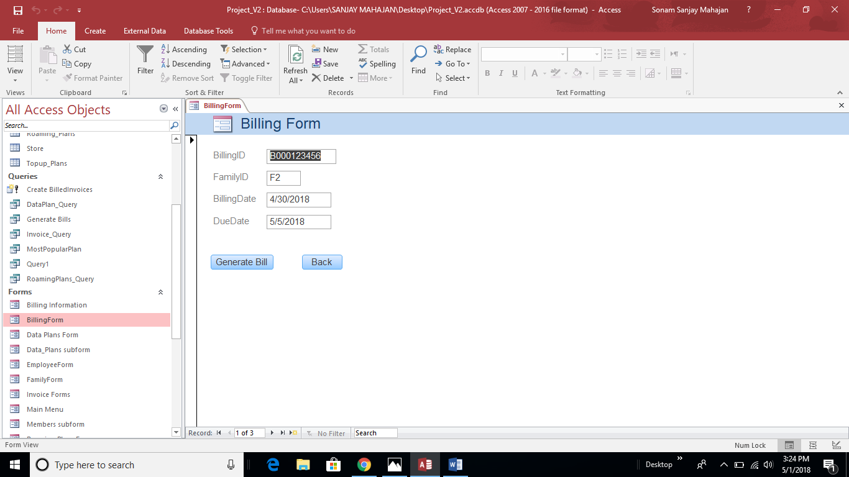

5.5 Data Plan Form

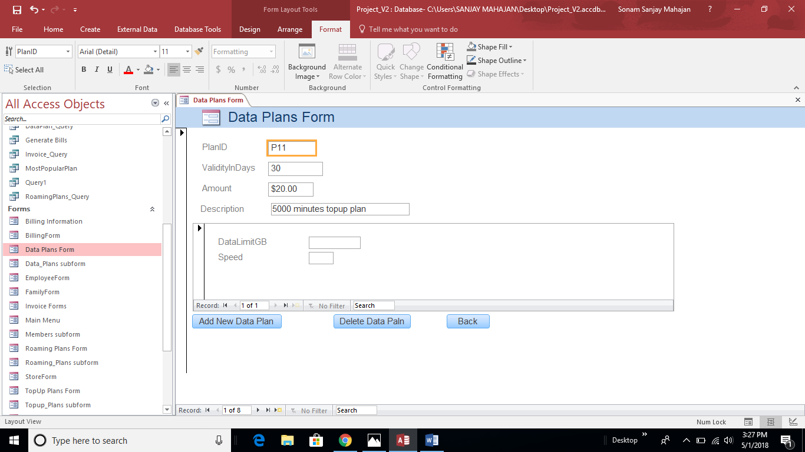

5.6 Roaming Plan Form

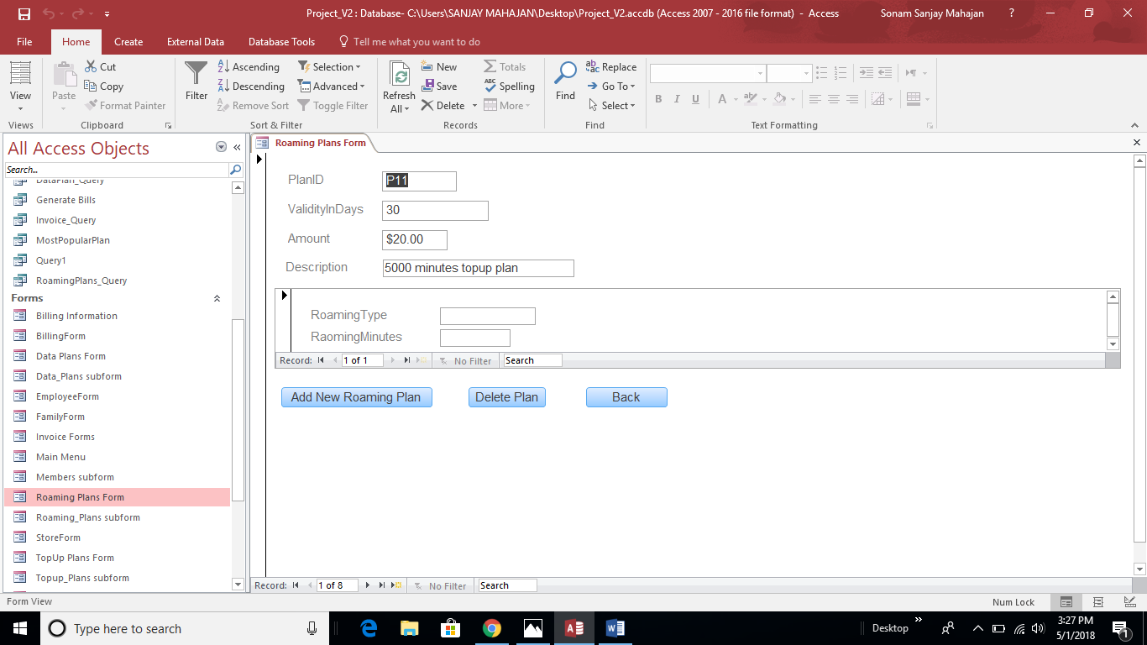

5.7 TopUp Plan Form

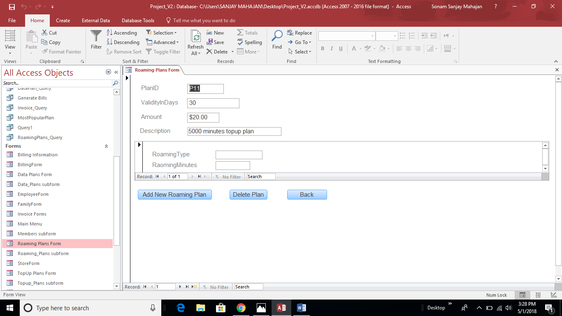

5.8 Invoice Form

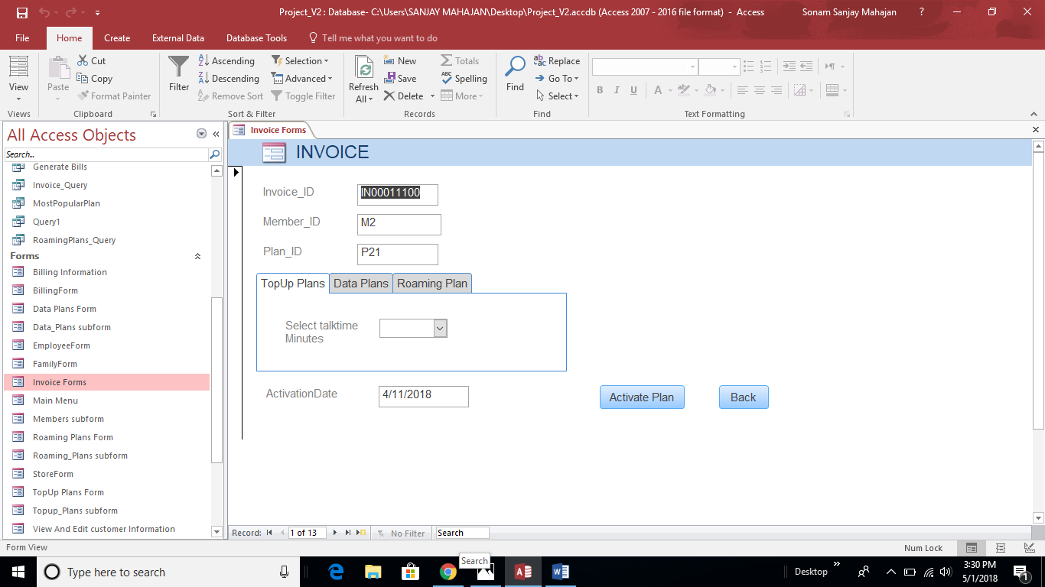

**6. Sample Reports**

6.1 Customer Billing Report

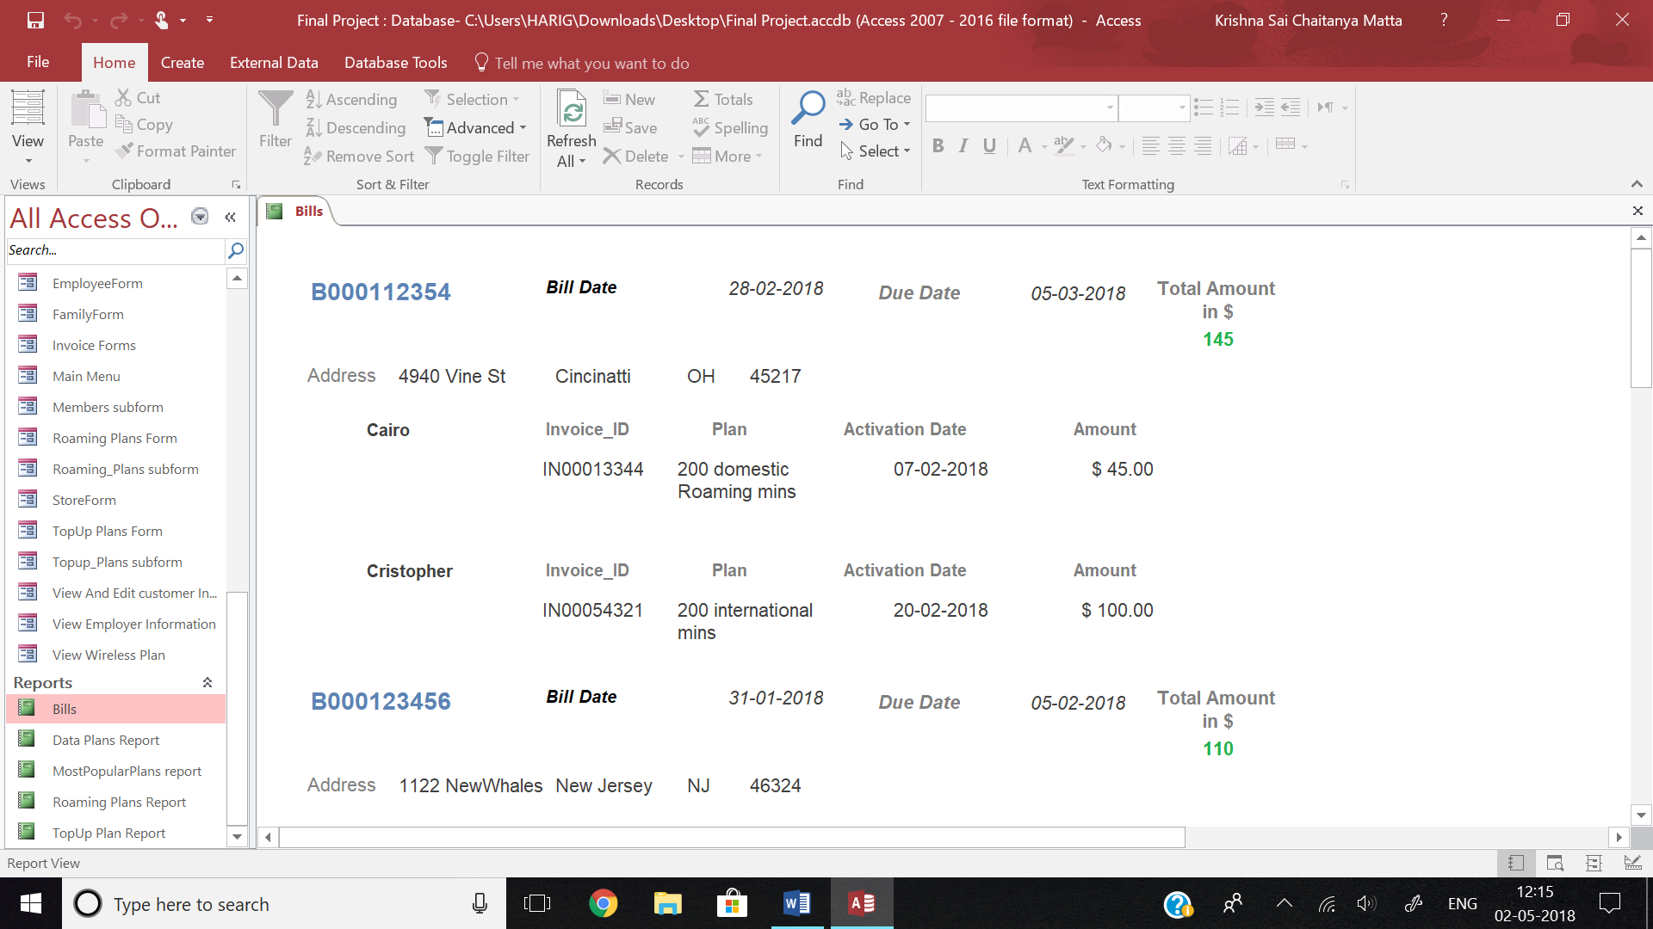

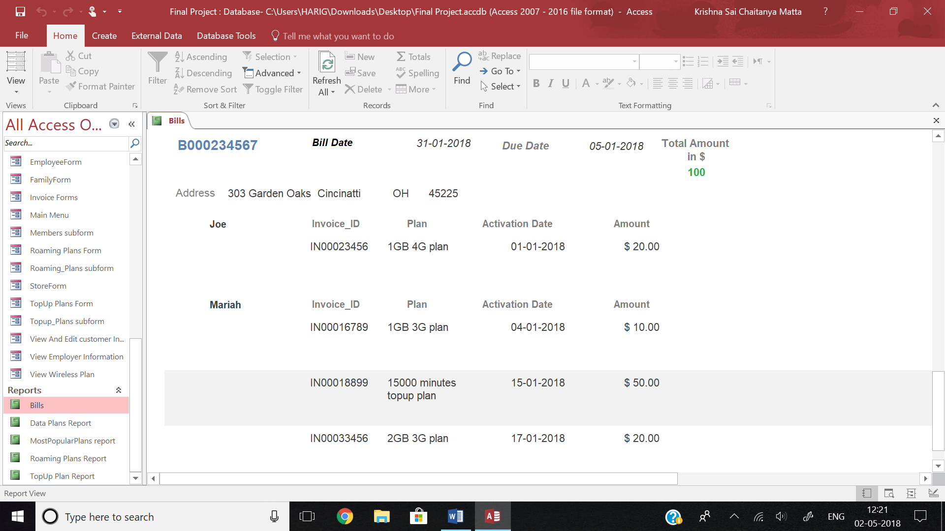

6.2 Data Plan Report:

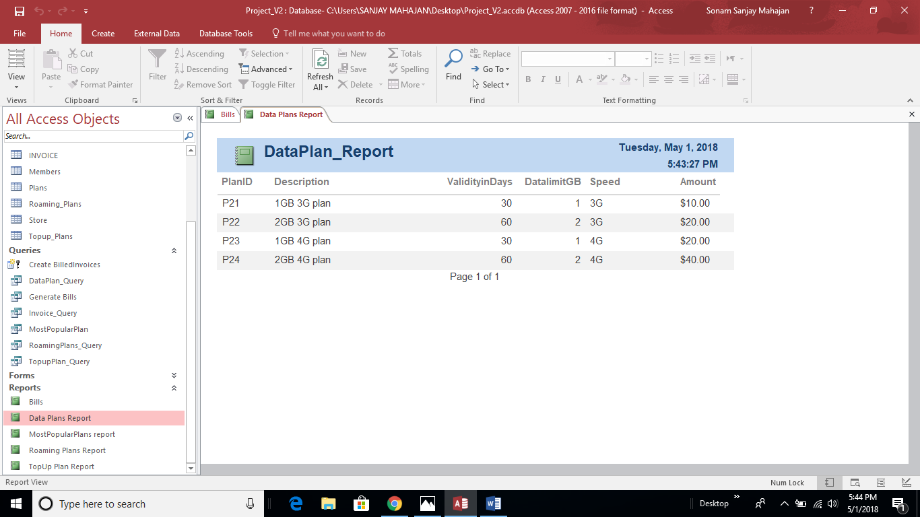

6.3 TopUp Plan

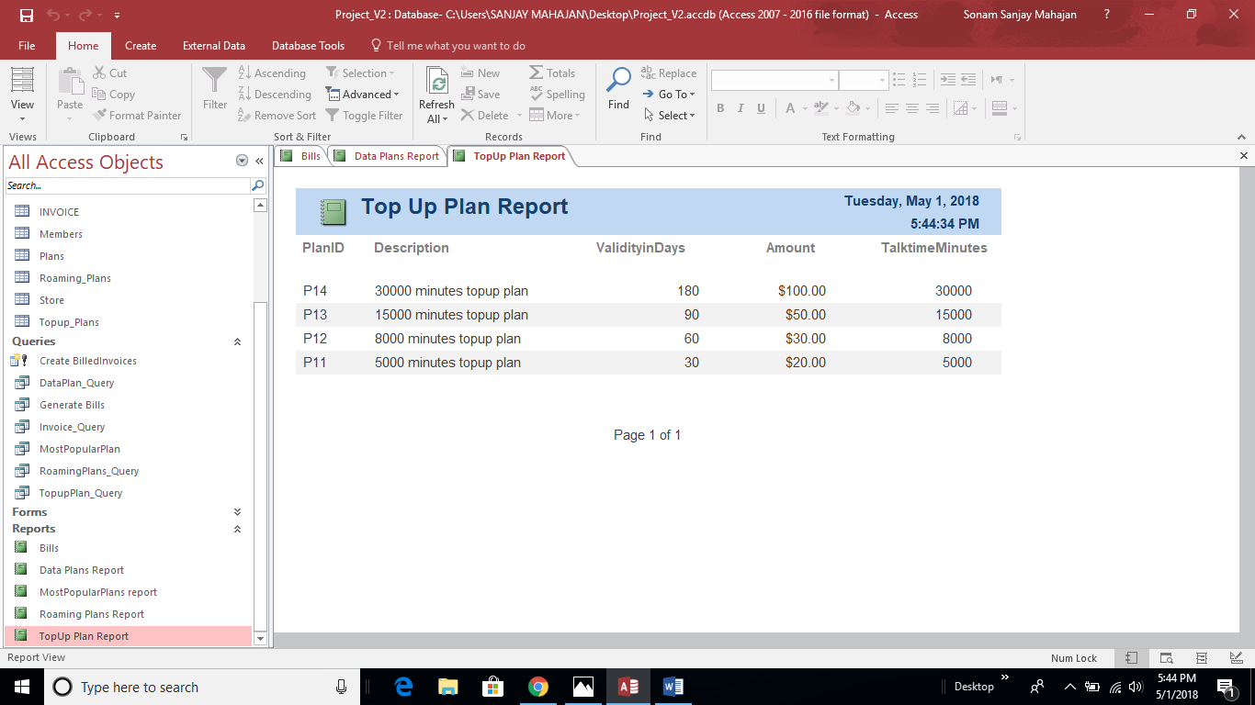

6.4 Roaming Plan

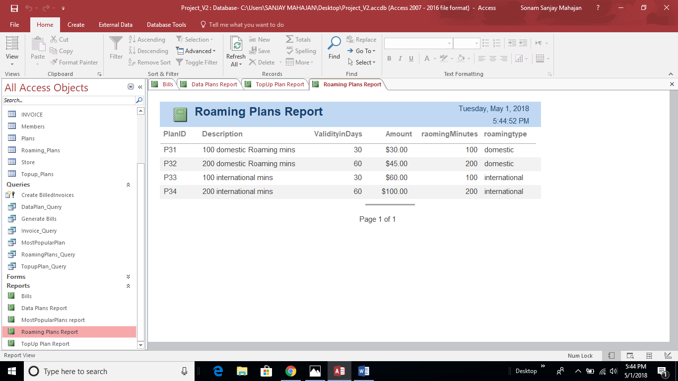

6.5 Most Popular Plan

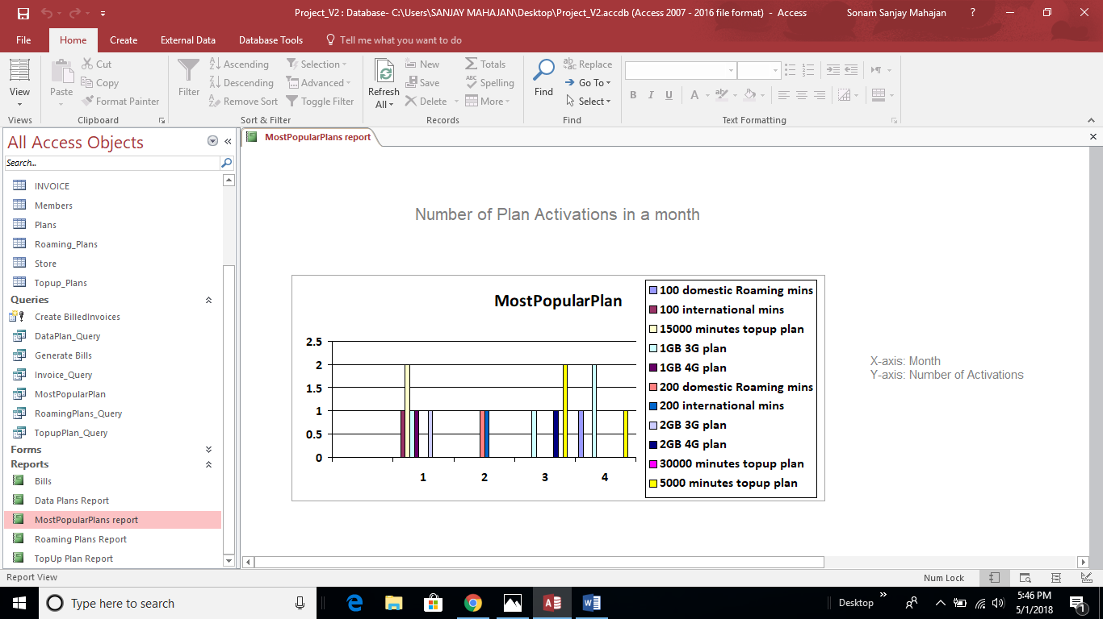

The database enables to determine the popularity of the different plans launched by Spirit in the Market. This is assessed by means of the number of activations for each of the plans. For example from the above chart it can be inferred that Sprints: 15000 Minutes top up plan, 5000 minutes top up plan and the 2GB 3G plan have maximum activations. The chart also gives Realtime information of the plans which are doing poorly and needs to have features which are more appealing to the customers, for example the 8000 minutes top up plan and the 30,000 minutes top up plan have zero activations.

**7.Menu**

7.1 Main Menu

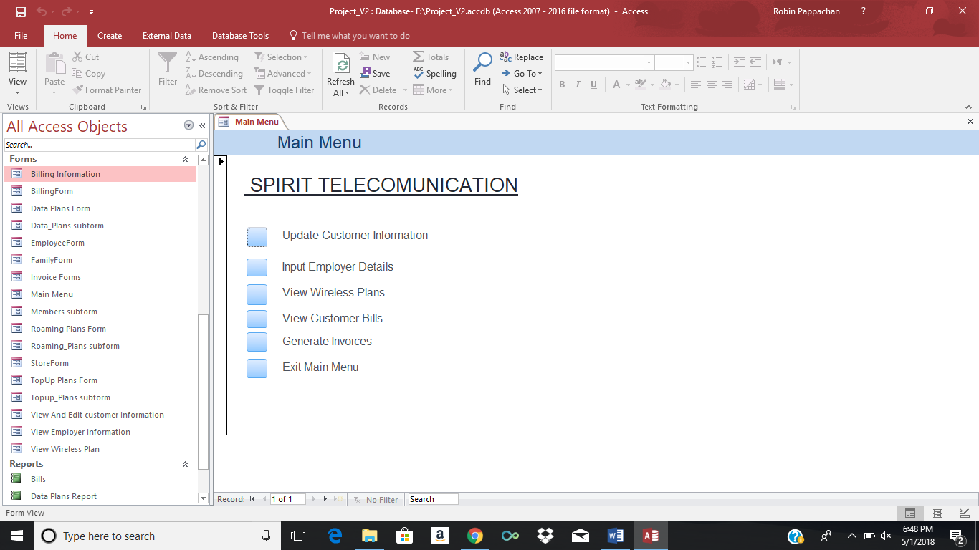

7.2 Update Customer Information

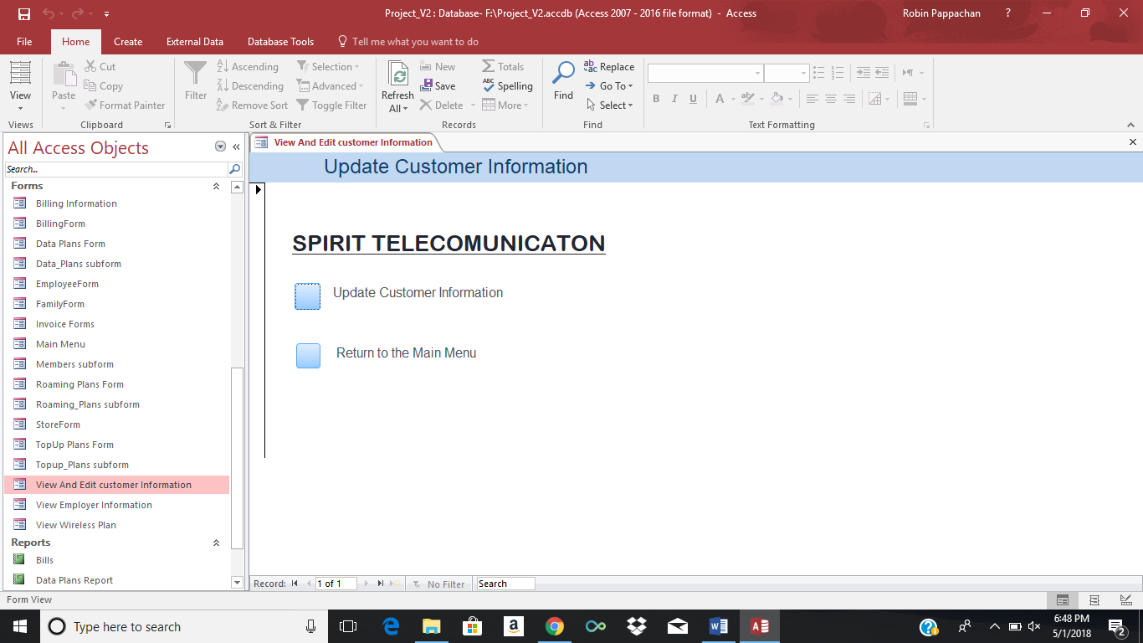

7.3 View Employee Information

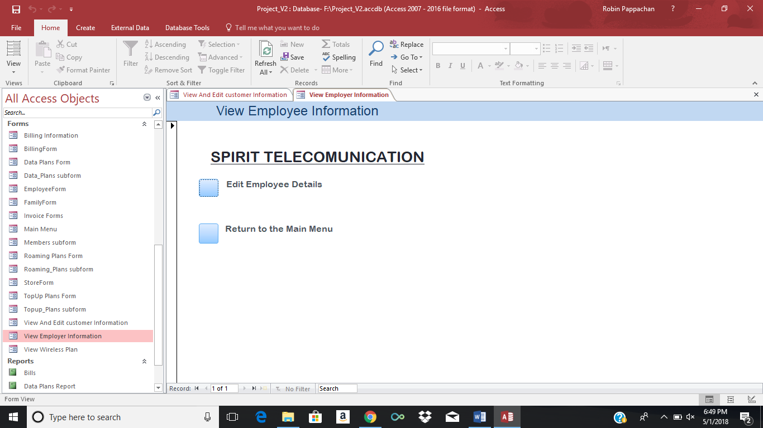

7.4 Wireless Plan

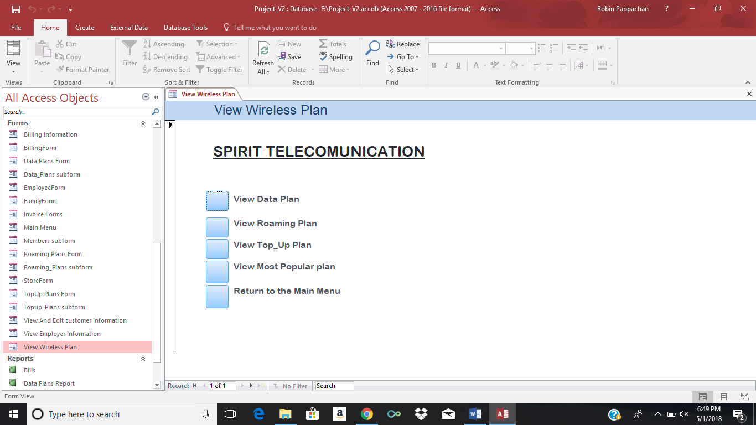

7.5 View Billing Information

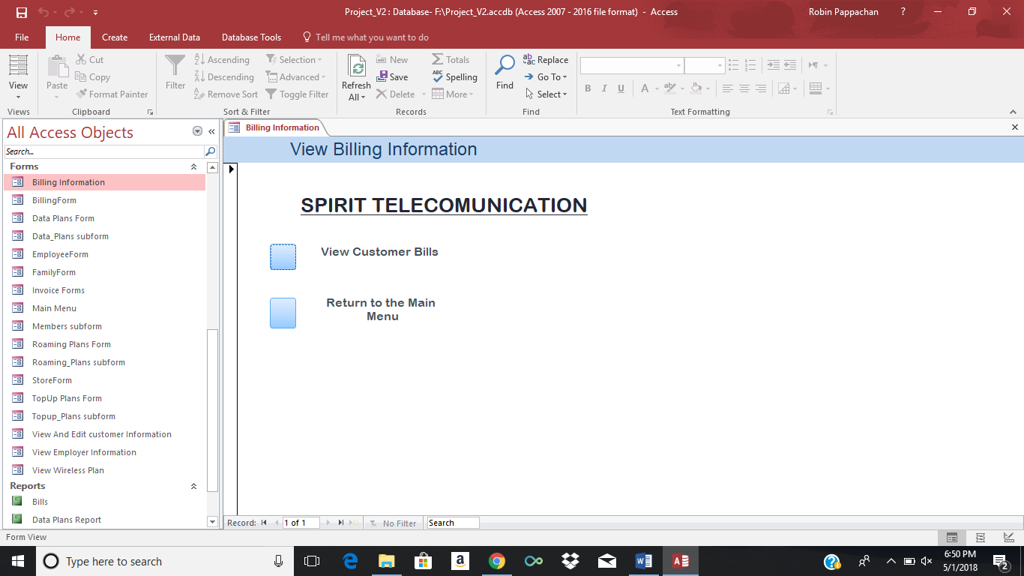

**8. Contributions**

|  |  |
| --- | --- |
| **Task** | **Contributors** |
| Organization History | Robin, Sonam |
| Problem Identification and Solution | Group |
| Database scope | Chaitanya, Robin |
| Table Description | Sonam, Samuel |
| Entity Relationship diagram | Sonam, Samuel |
| Relational Database schema | Chaitanya, Robin |
| Family hierarchical Form, Invoice Form, Stores form | Chaitanya, Sonam |
| Plans hierarchical form, Billing form, Employee form | Robin, Samuel |
| Billing Report | Chaitanya, Samuel |
| Topup Plan, Raoming Plan, Data Plan reports | Sonam |
| MostPopularPlans report | Robin |
| Main Menu | Sonam,Samuel,Chaitanya |